**Meet the Team**

**Craft Cube**

Mission Statement



**2 in 1 CNC Machine**

**Ammar Ahmed-** Ammar is a senior, majoring in Electrical Engineering at Sacramento State University. His focus is in control systems with a small emphasis in Analog IC Design. His contribution towards the project was the development of the computer vision system. This system was implemented on OpenCV-Python to get the dimension and location of the object in the working space. Currently, he is a member of the Hornet Hyperloop club, IEEE, and Tau Beta Pi (Engineering Honor Society).

*Email*: Ammarfa1993@hotmail.com

**Thomas Bock-** Thomas is a second semester senior majoring in Electrical Engineering at Sacramento State, with a focus on control systems. His contribution to the project was the design and construction of the frame and linear motion system of the Craft Cube. This system allows for accurate and reliable motion of the end effector.

*Email:*

**Michael Golez-** Michael is a senior engineer at California State University, Sacramento, majoring in Electrical Engineering. His primary focus is Digital/Analog Systems with a small emphasis in Control Theory. In the design of the CNC laser system, his contributions include the powering and operation of the laser diode and laser control circuitry. This involved designing and implementing a constant current source that can operate the laser safely.

*Email*:

**Tan Hua-** Tan is a Communication System Engineer with a minor focus on Digital Signal Processing. Over the years at Sacramento State, he spent time practicing software development. Currently he is working as an I.T. support for the state. As a result, his main focus towards the project would be the software implementation towards controlling the CNC laser system.

*Email:*

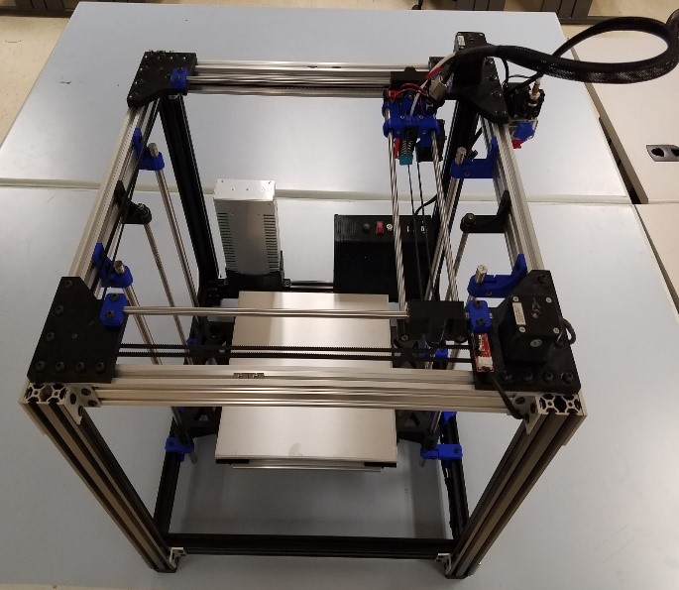

Craft Cube is a low cost 2 in 1 CNC Machine that utilizes a user-friendly operating. The design of the machine is constructed through parts 3D-printed or available online. A camera aide is mounted on the platform in order to assist the machine in detecting the dimensions of the object.

California State University, Sacramento

Senior Design Project

Fall 2016

EEE193B/CPE191



**Craft Cube System Operation**